##### DORE SHOW Entry Form

Name…………………………………….....

----------------------------------------------------------

Class…………... Entry No. ………...

Judges’ comments For Auction? Y / N

.......................................................................

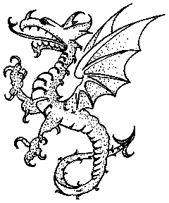

##### DORE SHOW Entry Form

Name…………………………………….....

----------------------------------------------------------

Class…………... Entry No. ………...

Judges’ comments For Auction? Y / N

.......................................................................



Revise the layout

##### DORE SHOW Entry Form

Name…………………………………….....

----------------------------------------------------------

Class…………... Entry No. ………...

Judges’ comments For Auction? Y / N

.......................................................................



##### DORE SHOW Entry Form

Name…………………………………….....

----------------------------------------------------------

Class…………... Entry No. ………...

Judges’ comments For Auction? Y / N

.......................................................................



##### DORE SHOW Entry Form

Name…………………………………….....

----------------------------------------------------------

Class…………... Entry No. ………...

Judges’ comments For Auction? Y / N

.......................................................................



##### DORE SHOW Entry Form

Name…………………………………….....

----------------------------------------------------------

Class…………... Entry No. ………...

Judges’ comments For Auction? Y / N

.......................................................................

