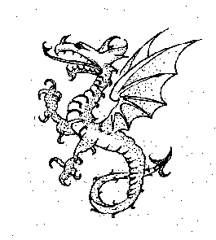

DORE VILLAGE SOCIETY ANNUAL GENERAL MEETING

Notice is hereby given that the 60th Annual General Meeting of the Dore Village Society will be held in Christ Church Dore, Church Lane at 7.30pm on Wednesday 11th June 2025.

Agenda

- Apologies for absence

- Approval of the minutes of the 59th Annual General Meeting

- To approve the Trustees' report

- To approve the accounts for the year ended 31st December 2024

- To approve an amendment to the constitution

- To elect up to 4 committee members

- Any other business

- Guest speaker

Guest speaker

Our guest speaker, Barry Starmore, of Starmore Boss, a bespoke off-licence retailing specialist quality wines, will present a talk about English wines. This will be followed by a wine tasting. Donations made at the event will go to More in Dore.

Notes

- Non-members of the Society are welcome to attend the meeting but will not be entitled to vote.
- The Trustees’ report, the annual accounts and the Independent Examiner’s report will be on the DVS website shortly at www.dorevillage.co.uk They and can also be obtained on request by email to agm@dorevillage.co.uk
- The Society’s constitution requires nominations for election to the committee to be made no later than 14 days prior to the meeting. Consequently nominations, together with a proposer, a seconder and a brief résumé of relevant background must be received no later than 6pm on Wednesday 28th May.
- If you wish to stand for election to the committee nomination forms can be obtained from the DVS website via the above link, or any of the current committee members (see our website and page seven of Dore to Door). Nominees, proposers and seconders must be members of the Dore Village Society at the time of nomination and at the time of the AGM.
- Completed nomination forms can be given to any member of the DVS committee or delivered to our address: The Old School, Savage Lane, Sheffield S17 3GW.
- A list of those nominated will be placed on the Society’s website and noticeboards at least seven days prior to the AGM.

Jen Donnelly
Chair, Dore Village Society

